

DB Linux server validation steps(standalone)
Oracle 19c database version

Project



DISCLAIMER

This document is strictly private, confidential and personal to its recipients and should not be copied, distributed or reproduced in whole or in part, nor passed to any third party.

Version history
Date | Version | Description | Author
2021-11-22 | 1.0 | Initial Version | Karthikeyan Saravanan
2021-11-26 | 1.1 | Updated version | Sharang Dwivedi

Contents
Version history 3
1. Introduction 5
2. Prerequisite 5
3. grid binary installation 6
4. Post installl validation 26

Introduction

This document describes the steps to install the 19c grid software on standalone server and ASM configuration.

validation steps

- Check whether oracle and grid users are created in server and oracle/grid users should be able to switch to root user.

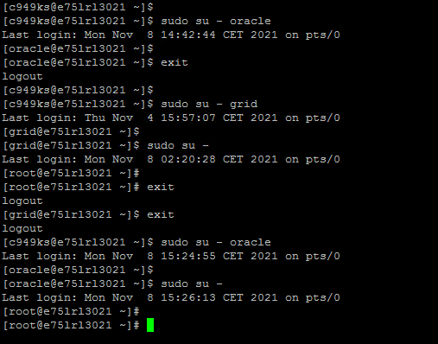

- Check whether below packages are installed.

- Zip/Unzip package • bc
- Binutils • elfutils-libelf-devel
- fontconfig-devel • glibc
- glibc-devel • ksh
- libaio • libaio-devel
- libXrender • libX11
- libXi • libXau
- libXtst • libgcc
- libnsl • librdmacm
- libstdc++ • libstdc++-devel
- libxcb • libibverbs
- smartmontools • make
- sysstat
rpm -qa | egrep -i "Zip|Unzip|bc|binutils|elfutils-libelf|elfutils-libelf-devel|fontconfig-devel|glibc|glibc-devel|ksh|libaio|libaio-devel|libXrender|libX11|libXau|libXi|libXtst|libgcc|libnsl|librdmacm|libstdc++|libstdc++-devel|libxcb|libibverbs|make|smartmontools|sysstat"
rpm -qa | grep -i Zip
rpm -qa | grep -i Unzip
rpm -qa | grep -i bc
rpm -qa | grep -i binutils
rpm -qa | grep -i elfutils-libelf
rpm -qa | grep -i elfutils-libelf-devel
rpm -qa | grep -i fontconfig-devel
rpm -qa | grep -i glibc
rpm -qa | grep -i glibc-devel
rpm -qa | grep -i ksh
rpm -qa | grep -i libaio
rpm -qa | grep -i libaio-devel
rpm -qa | grep -i libXrender
rpm -qa | grep -i libX11
rpm -qa | grep -i libXau
rpm -qa | grep -i libXi
rpm -qa | grep -i libXtst
rpm -qa | grep -i libgcc
rpm -qa | grep -i libnsl
rpm -qa | grep -i librdmacm
rpm -qa | grep -i libstdc++
rpm -qa | grep -i libstdc++-devel
rpm -qa | grep -i libxcb
rpm -qa | grep -i libibverbs
rpm -qa | grep -i make
rpm -qa | grep -i smartmontools
rpm -qa | grep -i sysstat
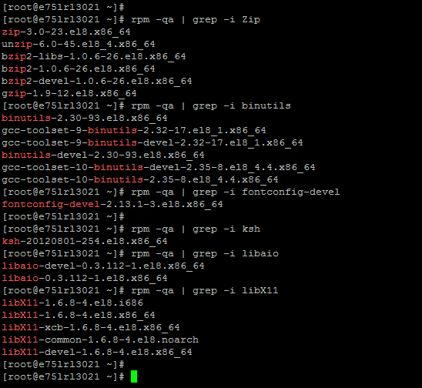

- Check entries in this file /etc/sysctl.conf (Kernel parameter setting) on server
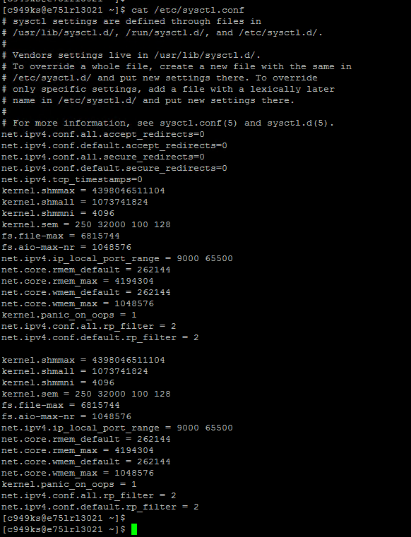
- Check entries in /etc/security/limits.conf on server
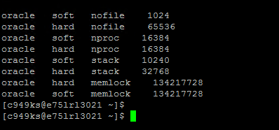

- Check for groups (cat /etc/group )

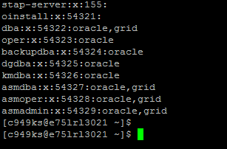

- Local storage on Server(df -h)
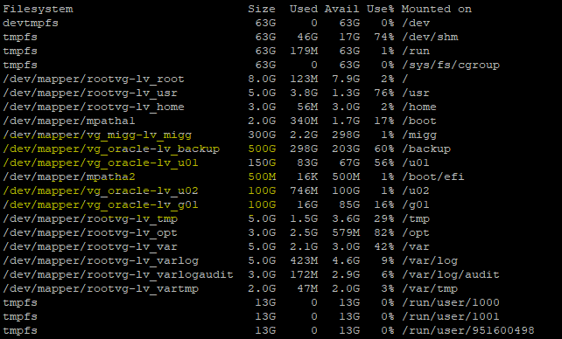

- ASM disks
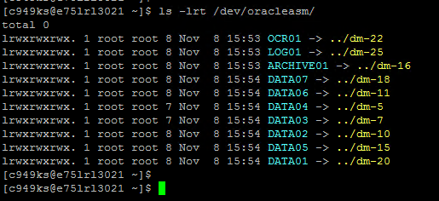

- IP and Hostname should resolve each other
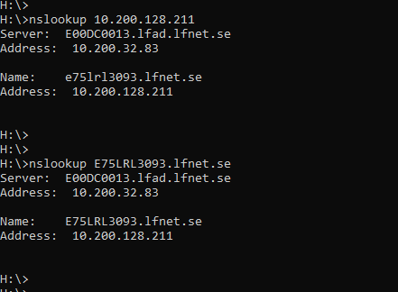

- SELinux parameter should be permissive.
cat /etc/sysconfig/selinux
(or ) getenforce

- Check whether firewall opened between catalog server and OEM server, if not raise request accordingly.

- Validate the server date with your system date.

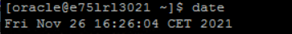
- In case of old server rebuild check the file system uses, service status etc.
ps -ef|grep pmon
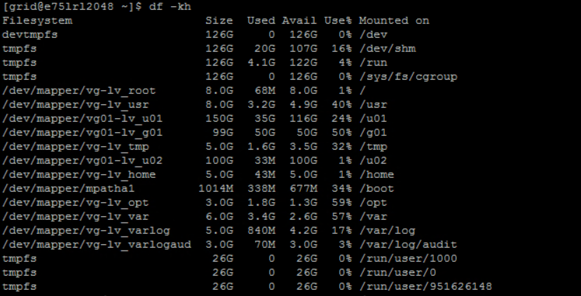

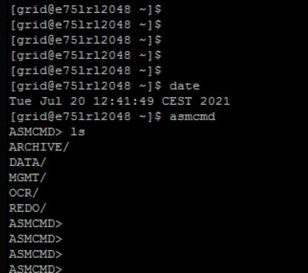

- Please unset below flags from /tmp mount
nosuid, nodev, noexec
mount|grep /tmp

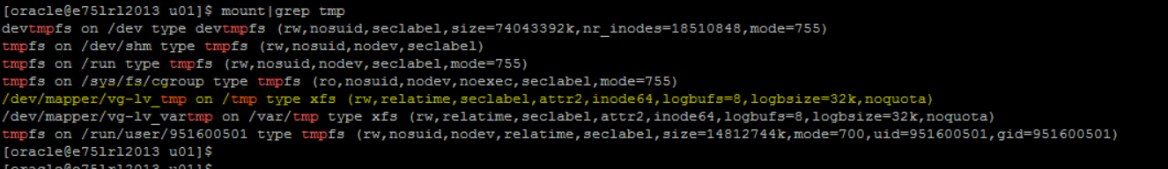

14.Change umask value to 022.

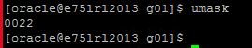

15.Verify if xauth is installed.

cd /usr/bin
ls -lrt xauth
16. Verify owners of disks in /dev location

Owner should be grid:asmadmin in /dev location
Owner should be root in /dev/oracleasm location

17. Verify all ASM disk should be CANDIDATES. If not ask UNIX team to format the disk

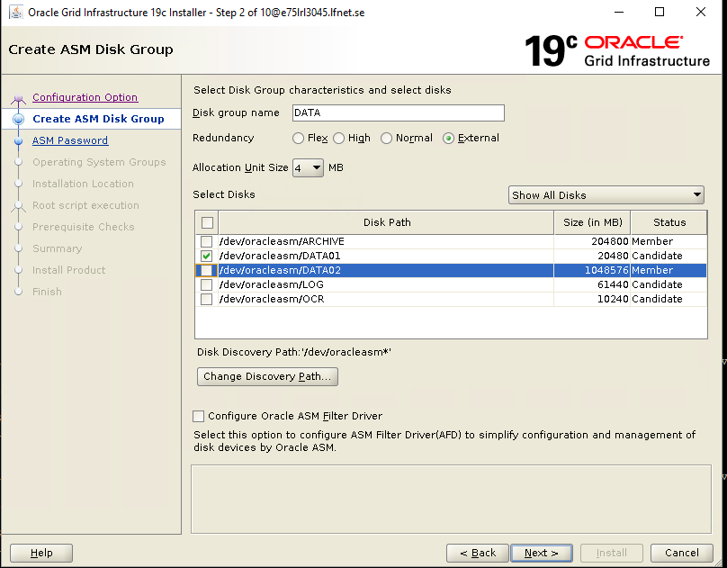

END OF DOCUMENT

